Year 11 Chemistry Name:

Rates of Reaction Extended Response

Total marks available: 40

**Question 1** (15 marks)

An experiment was designed in order to determine the rate of reaction between marble chips (mostly composed of calcium carbonate, (CaCO3) and hydrochloric acid). The equipment was set up as shown in the diagram below. 5.00 g of marble chips were placed into a conical flask containing excess hydrochloric acid and the mass of the flask was weighed at intervals until the reaction had completely stopped. The results were recorded in the table.

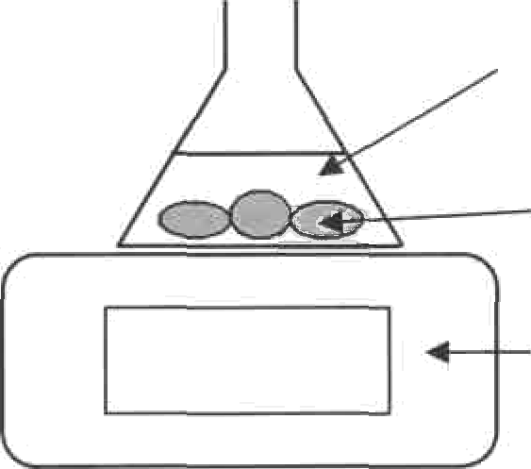hydrochloric acid marble chips

|  |  |
| --- | --- |
| Time (s) | Mass (g) |
| 0 | 185.0 |
| 2 | 184.2 |
| 5 | 183.6 |
| 10 | 183.4 |
| 15 | 183.3 |
| 20 | 183.2 |
| 30 | 183.2 |

185.0 g

balance

1. Write a balanced equation for the reaction used in this experiment.

CaCO3 + 2HCl 🡪 CaCl2 + H2O + CO2

Correct equation 1 mark

Correct balancing 1 mark

1. Draw a graph that illustrates the results of this experiment.

(2 marks)

(4 marks)

Title 1 mark

Axis labels 1/2 mark

Axis units 1/2 mark

Correctly plotted (levels off after 20 seconds) 1 mark

X axis for time ½ mark, Y axis for mass ½ mark

1. Explain, in terms of the collision theory, why the reaction rate changes as the reaction progresses. How is this change in reaction rate related to the shape of the graph? (3 marks)

The reaction rate **slows down** as the reaction progresses (1 mark)

This is because there are **more reactant particles** present at the start (1 mark)

There are therefore **fewer collisions** as the reactant particles are used up (1 mark)

# What test could you perform to confirm the identity of the gas produced and what result would indicate a positive test result? (1 mark)

Bubbling the carbon dioxide through colourless **limewater (Calcium hydroxide)** to make the white precipitate calcium carbonate and water resulting in a **cloudy solution**

1. Calculate the mass of carbon dioxide produced from the marble chips.

185-183.2 = 1.8g CO2

1. Calculate the percent by mass of calcium carbonate in the marble chips.

mCO2 = 1.8g

n (CO2) = 1.8/44.01 = 0.0409 mol (1 mark - carry through CO2 mass mistake from 1e if applicable)

n(CO2) = n(CaCO3) (1 mark – carry through balancing mistake from 1a if applicable)

m(CaCO3) = nM = 0.0409 x 100.09 = 4.09g (1 mark)

4.09g CaCO3/5.00g Marble Chips x 100 = 81.9% purity (1 mark)

(1 mark)

(4 marks)

**Question 2** (9 marks)

Most modern cars are powered by an engine with a 4-stroke combustion cycle. The purpose of each stroke is described below.

* 1. Intake stroke - the fuel is injected in as a fine mist, where it mixes with air
  2. Compression stroke - the fuel/air mixture is compressed into a small volume
  3. Combustion stroke - a spark plug ignites the fuel/air mixture, which explodes
  4. Exhaust stroke exhaust fumes leave through the valve

Explain, in terms of the collision theory, how each of the conditions described in stroke 1, 2 and 3 affect the rate of reaction between the fuel and the air.

|  |  |
| --- | --- |
| Stroke | Explanation |
| 1 | Fuel is injected as a fine mist **increasing the surface area** of the fuel molecules before it reacts with air (1 mark)  The finer the mist, a **greater number of air molecules can surround** the fuel molecules. (1 mark)  The increased surface area **increases the chance of** **successful collisions** (1 mark) |
| 2 | The fuel/air mixture is compressed into a small volume, hence the **concentration/pressure increases** (1 mark)  Due to there being a higher concentration/pressure of fuel and air molecules, the **number of collisions will increase** (1 mark)  This increases the rate of reaction as there are more **successful** **collisions** in the same amount of time. (1 mark) |
| 3 | The exploding fuel/air mixture **increases the temperature** of the system (1 mark)  The increase in temperature causes an **increase in kinetic energy** in the reactant molecules (1 mark)  The increase in kinetic energy causes a greater number of successful collisionsas the particles have an energy greater than the activation energy (1 mark)  OR  The spark plug acts as a **catalyst** for the fuel/air reaction (1 mark)  The spark plug **lowers the activation energy** needed for the air/fuel to combust (1 mark)  **More molecules will have enough energy** to be able to collide effectively to make products (1 mark) |

**Question 3** (16 marks)

Read the following information regarding catalytic converters and use it where necessary to help you to answer the questions that follow.

*There are millions of cars on the road, and each one is a source of air pollution. Especially in large cities, the amount of pollution that all the cars produce together can create big problems. To solve these problems, cities, states and the government have created clean-air laws that restrict the amount of pollution that cars can produce. Over the years, car manufacturers have made many refinements to car engines and fuel systems to keep up with these laws. One of these changes came about in 1975 with a device called*

***a catalytic* converter.** *The job of the catalytic converter is to convert harmful pollutants into less harmful emissions before they leave the car’s exhaust system.*

*The main emissions of a car engine are:*

* *Nitrogen gas (N2) - Air is 78% nitrogen gas, and most of this passes right through the car engine.*
* *Carbon dioxide (CO2) - This is one product of combustion. The carbon in the fuel bonds with the oxygen in the air.*
* *Water vapour (H2O) - This is another product of combustion. The hydrogen in the fuel bonds with*

*the oxygen in the air.*

*These emissions are mostly benign, although carbon dioxide emissions are believed to contribute to global warming. Because the combustion process is never perfect, some smaller amounts of more harmful emissions are also produced in car engines. Catalytic converters are designed to reduce all three:*

* *Carbon* monox/c/e *(CO) is a poisonous gas that is colourless and odourless. It is produced when hydrocarbons are burnt in a limited supply of oxygen*
* ***Hydrocarbons*** *or* **vo/afi/e *organic*** *compounds (VOCs) are a major component of smog produced mostly from evaporated, unburned fuel*
* **/\/ifrogen** *oxides (NO and NOT, together called NOx) are a contributor to smog and acid rain, which also causes irritation to human mucus membranes. These are produced when nitrogen gas is mixed with oxygen gas at high temperatures like those experienced in a car engine*

NO,

hydrocarbons CO

N2 H2

CO2

catalytic converter

*The catalytic conveder commonly contains minute padicles of Pt, Pd and Rh coated onto the surface of a ceramic suppod that has a honeycomb structure. The Pd is responsible for catalysing the exothermic reaction between CO and Oy to produce CO whereas the Rh catalyst speeds up the reaction between the pollutants CO and NO* fo *produce COC and Nd*

1. Describe and explain the effect of a catalyst on the rate of a reaction.

(3 marks)

A catalyst **lowers the activation energy** needed for a reaction to occur (1 mark)

If the activation energy is lowered, **more molecules will have enough energy** to be able to collide effectively to make products (1 mark)

The increase in molecules having successful collisions increases the rate of reaction without using up the catalyst itself (1 mark)

1. In the space below draw a reaction profile diagram for an **endothermic reaction** to demonstrate how a catalyst works. For maximum marks, make sure your diagram is clearly labelled and has all necessary sections included. (4 marks)

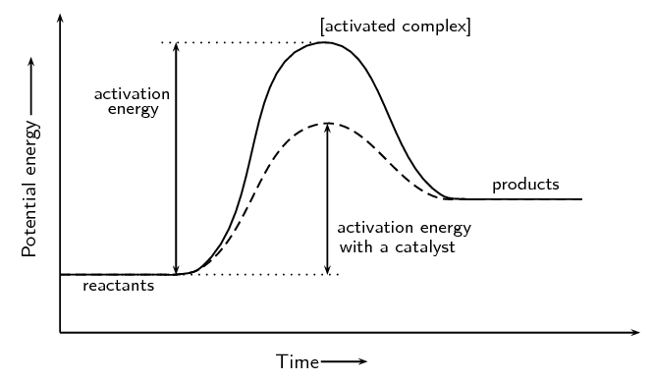

Axis labels (1 mark)

Activation energy labelled (1 mark)

Reactants lower than products (1 mark)

Catalyst reducing activation energy (1 mark)

1. Write a balanced equation for the production of the following two gases by the engine of a motor car. In the first reaction you can assume the hydrocarbon fuel being burnt is pure octane.(2 marks)

|  |  |
| --- | --- |
| Reaction producing CO (carbon monoxide) | C8H18 + 8.5O2 🡪 8CO + 9H2O  or  2C8H18 + 17O2 🡪 16CO + 18H2O |
| Reaction producing NO  (nitrogen monoxide) | N2 + O2 🡪 2NO |

1. Using information from the final paragraph of the text, write balanced equations for the reactions catalysed by Pd and Rh. (2 marks)

|  |  |
| --- | --- |
| Reaction catalysed by Pd | Pd  2CO + O2 🡪 2CO2 |
| Reaction catalysed by Rh | Rh  2CO + 2NO 🡪 2CO2 + N2 |

1. The symbols Pd and Rh are for which two elements?

Palladium and Rhodium

(1 mark)

1. What is the general name given to the group of elements (many of which make excellent catalysts) to which these belong? (1 mark)

Transition metals

1. Explain why the Pd and Rh are coated onto the surface of the ceramic support material and why the structure has a honeycombed shape as shown in this diagram. (2 marks)

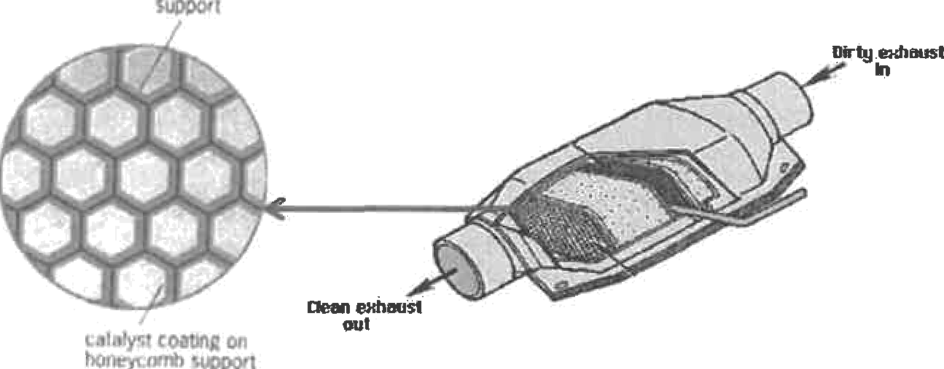

The honeycomb structure provides **high surface area**, which **maximizes the contact between the catalysts and the pollutants** in the hot exhaust gases.

1. From a chemical point of view, explain why the catalytic converter in a motor vehicle should last the lifetime of the vehicle. (1 mark)

Catalysts are never consumed in a chemical reaction.